**Chapter 2 Tables and Figures**

**Table 1:** Mean grain yields (t ha-1), grain yield standard deviation (), number of environments where variety was tested (Env), number of environments where variety outperforms check (n), mean yield differences (), standard deviation of differences () and Reliabilities (, ) for the experimental hybrids across the three years with commercial variety, 59R5 as the check.

|  |  |  |  |  |  |  |  |  |
| --- | --- | --- | --- | --- | --- | --- | --- | --- |
| Experimental Hybrid | Mean Yield  (t ha-1) |  | Env | n |  |  |  |  |
| KEV1 | 8.14 | 3.40 | 7 | 2 | -1.63 | 2.17 | 0.226 | 0.286 |
| KEV2 | 7.34 | 1.80 | 7 | 1 | -2.43 | 1.63 | 0.068 | 0.143 |
| KEV3 | 8.31 | 2.10 | 7 | 1 | -1.47 | 1.37 | 0.142 | 0.143 |
| ORG1 | 7.89 | 1.94 | 19 | 5 | -2.16 | 2.39 | 0.183 | 0.263 |
| ORG2 | 6.85 | 2.12 | 6 | 1 | -3.16 | 1.67 | 0.030 | 0.167 |
| ORG4 | 8.59 | 2.25 | 19 | 6 | -1.46 | 2.35 | 0.267 | 0.316 |
| ORG5 | 7.31 | 2.55 | 6 | 0 | -2.69 | 1.75 | 0.062 | 0.000 |
| UIUC1 | 9.85 | 1.28 | 13 | 5 | -0.22 | 2.56 | 0.465 | 0.385 |
| UIUC2 | 10.23 | 2.21 | 13 | 6 | 0.16 | 2.20 | 0.528 | 0.462 |
| UIUC3 | 10.52 | 1.55 | 13 | 7 | 0.45 | 2.98 | 0.559 | 0.538 |
| UIUC4 | 10.36 | 1.05 | 13 | 7 | 0.28 | 3.04 | 0.537 | 0.538 |
| UIUC7 | 8.35 | 2.30 | 13 | 2 | -1.73 | 2.54 | 0.248 | 0.154 |
| 59R5 | 9.97 | 2.80 | 20 | - | - | - | - | - |

**Table 2:** First stage analysis of variance, means, standard errors (SE), minimum (min) and maximum (max) values of the measured morpho-physiological traits for the three years.

|  |  |  |  |  |  |  |  |  |
| --- | --- | --- | --- | --- | --- | --- | --- | --- |
| Trait | Units | Mean | SE | Min | Max | Source of Variation | | |
|  | | | | | | FAR | HYB | F: H |
| Grain Yield | t ha-1 | 9.1 | 0.1 | 1.6 | 14.8 | 0.01 | < 0.001 | < 0.001 |
| Plant Height | cm | 232.6 | 1.1 | 105.0 | 330.0 | 0.212 | < 0.001 | < 0.001 |
| Ear Height | cm | 108.1 | 0.7 | 45.0 | 177.0 | 0.661 | < 0.001 | < 0.001 |
| SDL | mm | 21.4 | 0.1 | 14.1 | 29.3 | < 0.001 | < 0.001 | < 0.001 |
| SDS | mm | 19.3 | 0.1 | 11.6 | 25.9 | < 0.001 | < 0.001 | < 0.001 |

Abbreviations: SDL, Large stalk diameter; SDS; small stalk diameter, FAR; Farmer effect, HYB; Hybrid effect, F:H; Farmer and Hybrid interaction.

**Table 3:** Morpho-physiological trait means for each year and mean comparison between years.

|  |  |  |  |  |  |
| --- | --- | --- | --- | --- | --- |
| Year | Morphological Trait Means | | | | |
|  | Grain yield  (t ha-1) | Plant height  (cm) | Ear height  (cm) | SDL  (mm) | SDS  (mm) |
| 2018 | 8.1 c | 228.4 b | 108.1 b | 21.2 a | 19.1 a |
| 2019 | 9.0 b | 226.4 b | 102.1 c | 21.6 a | 19.6 a |
| 2020 | 10.0 a | 241.4 a | 113.2 a | - | - |

Mean values with different letters are significantly different at alpha = 0.05. Abbreviations: SDL, Large stalk diameter; SDS; small stalk diameter.

**Table 4:** Morpho-physiological trait means for each farmer and mean comparisons between participating farmers in each growing period.

|  |  |  |  |  |  |
| --- | --- | --- | --- | --- | --- |
| Farmer | Morphological Trait Means for 2018 | | | | |
|  | Grain yield  (t ha-1) | Plant height  (cm) | Ear height  (cm) | SDL  (mm) | SDS  (mm) |
| B | 11.2 a | 254.8 a | 122.4 a | 24.6 a | 22.1 a |
| A | 9.0 b | 229.0 b | 108.4 bc | 18.9 d | 17.1 d |
| C | 8.1 b | 227.9 b | 113.1 b | 22.6 b | 20.3 b |
| F | 7.8 bc | 222.7 bc | 96.6 e | 21.6 bc | 19.4 bc |
| G | 6.8 c | 216.9 c | 101.8 de | 18.9 d | 17.2 d |
| E | 5.5 d | 219.1 c | 106.1 cd | 20.6 c | 18.7 c |
|  | Morphological Trait Means for 2019 - 2020 | | | | |
| L | 11.4 a | 225.9 d | 112.8 ab | - | - |
| F | 10.4 b | 237.3 c | 103.2 c | 21.0 b | 19.1 c |
| K | 10.1 bc | 236.7 c | 109.5 b | 23.9 a | 21.6 a |
| J | 9.9 bc | 257.2 a | 116.0 a | 21.3 b | 19.6 c |
| G | 9.7 bc | 238.1 c | 104.7 c | - | - |
| I | 9.4 cd | 247.3 b | 114.9 a | 23.1 a | 20.8 b |
| A | 8.7 d | 208.0 e | 94.3 d | 21.5 b | 19.5 c |
| H | 7.8 e | 223.9 d | 111.3 b | 18.5 c | 16.6 d |

Mean values with different letters are significantly different at alpha = 0.05. Abbreviations: SDL, Large stalk diameter; SDS; small stalk diameter.

**Table 5:** Morpho-physiological trait means for each hybrid and mean comparisons between hybrids grown in the same period.

|  |  |  |  |  |  |  |  |  |
| --- | --- | --- | --- | --- | --- | --- | --- | --- |
| Hybrid | Agronomic and Chemical Compositional Trait Means for 2018 | | | | | | | |
|  | **YLD**  **(t ha-1)** | **PHT**  **(cm)** | **EHT**  **(cm)** | **SDL**  **(mm)** | **SDS**  **(mm)** | **PROT**  **(%)** | **STA**  **(%)** | **OIL**  **(%)** |
| CHECK | 9.8 a | 248.8 a | 116.5 a | 21.6 a | 18.9 bc | 7.0 e | 73.3 a | 3.4 e |
| KEV1 | 7.9 bc | 219.5 cd | 105.1 c | 20.9 ab | 18.9 bc | 7.7 d | 71.9 b | 4.2 d |
| KEV2 | 7.3 cd | 229.4 bc | 107.3 bc | 21.7 a | 20.0 a | 8.4 bc | 71.0 c | 4.5 bc |
| KEV3 | 8.3 bc | 214.2 d | 94.2 d | 20.9 ab | 19.3 ab | 8.0 cd | 71.6 b | 4.3 cd |
| ORG1 | 7.2 cd | 231.7 b | 112.2 ab | 21.9 a | 19.6 ab | 8.7 b | 69.8 de | 4.8 a |
| ORG2 | 6.9 d | 228.3 bc | 108.5 bc | 21.8 a | 19.5 ab | 9.5 a | 69.2 e | 4.7 ab |
| ORG4 | 8.7 ab | 224.3 bc | 116.8 a | 21.9 a | 19.5 ab | 8.2 bc | 70.2 d | 4.7 a |
| ORG5 | 7.2 cd | 223.5 bc | 106.1 bc | 19.8 b | 18.0 c | 8.4 bc | 71.0 c | 4.1 d |
|  | Agronomic Chemical Compositional Trait Means For 2019 - 2020 | | | | | | | |
| CHECK | 10.1 ab | 242.6 ab | 106.6 ab | 21.9 ab | 19.6 ab | 7.9 ab | 73.8 a | 3.0 c |
| UIUC1 | 9.7 bc | 227.0 bc | 100.4 b | 20.8 bc | 19.0 bc | 7.5 b | 66.4 d | 3.6 b |
| UIUC2 | 10.5 a | 232.2 bc | 109.5 ab | 23.0 a | 20.9 a | 8.2 ab | 72.9 b | 3.5 bb |
| UIUC3 | 10.1 ab | 245.0 ab | 110.7 ab | 22.1 ab | 19.7 ab | 7.9 ab | 66.2 d | 3.5 bc |
| UIUC4 | 10.5 a | 256.1 a | 114.4 a | 20.9 bc | 19.1 bc | 8.3 ab | 72.6 b | 3.4 bc |
| UIUC7 | 8.7 cd | 232.4 bc | 103.5 ab | 22.3 ab | 20.2 ab | 7.8 ab | 65.6 d | 3.8 b |
| ORG1 | 8.2 d | 218.4 c | 105.8 ab | 20.6 c | 18.6 c | 8.2 ab | 64.5 e | 4.9 a |
| ORG4 | 8.6 cd | 223.7 bc | 113.3 ab | 21.3 bc | 19.5 ab | 8.6 a | 70.2 c | 4.6 a |

Mean values with different letters are significantly different at alpha = 0.05, Abbreviations: YLD: Grain Yield, PHT: Plant Height, EHT: Ear Height, SDL: Large Stem Diameter, SDS: Small Stem Diameter, PROT: Protein Content, STA: Starch Content, OIL: Oil content

**Table 6**: Phenotypic correlation for morpho-physiological and grain quality traits for the 2018-2019 testing period using Pearson correlation analysis. Grain quality components were obtained using Inframatic-9500 grain analyzer.

|  |  |  |  |  |  |  |  |  |  |  |  |
| --- | --- | --- | --- | --- | --- | --- | --- | --- | --- | --- | --- |
| Trait | PHT | EHT | SDL | SDS | MST | TWT | THKWT | YIELD | PROT | OIL | STR |
| PHT | 1 | 0.61*** | 0.6*** | 0.56*** | 0.13 | 0.2* | 0.21* | 0.55*** | 0.11 | -0.12 | 0 |
| EHT |  | 1 | 0.46*** | 0.4*** | 0.22* | -0.07 | 0.11 | 0.29** | 0.12 | 0.29** | -0.32*** |
| SDL |  |  | 1 | 0.97*** | -0.08 | 0.29** | 0.18 | 0.44*** | 0.25* | 0.01 | -0.12 |
| SDS |  |  |  | 1 | -0.12 | 0.32** | 0.17 | 0.39*** | 0.26** | 0.03 | -0.13 |
| MST |  |  |  |  | 1 | -0.21* | 0.17 | 0.07 | -0.03 | 0.19 | -0.1 |
| TWT |  |  |  |  |  | 1 | 0.36*** | 0.31** | -0.2* | -0.51*** | 0.55*** |
| THKWT |  |  |  |  |  |  | 1 | 0.32*** | 0.36*** | 0.04 | -0.18 |
| YIELD |  |  |  |  |  |  |  | 1 | 0.19 | -0.18 | 0.03 |
| PROT |  |  |  |  |  |  |  |  | 1 | 0.34*** | -0.73*** |
| OIL |  |  |  |  |  |  |  |  |  | 1 | -0.86*** |
| STR |  |  |  |  |  |  |  |  |  |  | 1 |

Statistically significant values are shown as different letters. * p <.05, ** p <.01 and *** p <.001.Abbreviations: PHT: Plant Height, EHT: Ear Height, SDL: Large Stem Diameter, SDS: Small Stem Diameter, MST: Moisture content, TWT: Test Weight, THKWT: 300 Kernel Weight, PROT: Protein Content, STR: Starch Content

**Table 7:** Phenotypic correlation for morpho-physiological and grain quality traits for the 2020 testing period using Pearson correlation analysis. Grain quality components were obtained using Perten DA 7200 NIR grain analyzer.

|  |  |  |  |  |  |  |  |  |  |
| --- | --- | --- | --- | --- | --- | --- | --- | --- | --- |
| Trait | PHT | EHT | MST | TWT | THKWT | YIELD | PROT | OIL | STR |
| PHT | 1 | 0.84*** | -0.37** | 0.44*** | 0.05 | 0.51*** | -0.31* | -0.32* | 0.5*** |
| EHT |  | 1 | -0.24 | 0.28* | 0.04 | 0.44*** | -0.26 | -0.15 | 0.36** |
| MST |  |  | 1 | -0.07 | 0.12 | 0.2 | 0.09 | -0.14 | -0.04 |
| TWT |  |  |  | 1 | 0.57*** | 0.59*** | 0 | -0.74*** | 0.64*** |
| THKWT |  |  |  |  | 1 | 0.46*** | 0.36** | -0.34** | 0.15 |
| YIELD |  |  |  |  |  | 1 | -0.19 | -0.55*** | 0.59*** |
| PROT |  |  |  |  |  |  | 1 | 0.05 | -0.61*** |
| OIL |  |  |  |  |  |  |  | 1 | -0.79*** |
| STR |  |  |  |  |  |  |  |  | 1 |

Statistically significant values are shown as different letters. * p <.05, ** p <.01 and *** p <.001.Abbreviations: PHT: Plant Height, EHT: Ear Height, SDL: Large Stem Diameter, SDS: Small Stem Diameter, MST: Moisture content, TWT: Test Weight, THKWT: 300 Kernel Weight, PROT: Protein Content, STR: Starch Content

|  |  |  |  |  |  |  |  |  |  |  |
| --- | --- | --- | --- | --- | --- | --- | --- | --- | --- | --- |
| **Source of Variation** | **DF** | **Mean Squares** | | | | | | | | |
|  |  | **Morpho-physiological Traits** | | | | |  | **Grain Quality Traits** | | |
|  | 12 | **Plant height** | **Ear**  **height** | **Grain**  **yield** | **Moisture content** | **Test weight** | **Kernel weight** | **Protein content** | **Starch content** | **Oil content** |
| Hybrid | 1647.7*** | 321.1*** | 17.2*** | 2.5*** | 84.0*** | 0.0024*** | 2.8*** | 21.0*** | 4.7*** |
| Year | 2 | 3068.0*** | 1784.7*** | 12.9** | 144.2*** | 49.7*** | 0.0233*** | 6.1*** | 596.4*** | 1.7*** |
| Manure Source | 5 | 3217.5*** | 1181.2*** | 33.0*** | 9.7*** | 42.8*** | 0.0068*** | 5.8*** | 7.6*** | 0.2 |
| Weed Pressure | 2 | 5479.2*** | 1509.1*** | 32.4*** | 2.8** | 35.9*** | 0.00004 | 0.1 | 0.8 | 0.1 |
| Cover crop Type | 3 | 4630.3*** | 1903.3*** | 12.5** | 31.2*** | 6.3 | 0.0050*** | 1.3* | 0.7 | 0.6** |
| Rot.Length | 1 | 171.3 | 71.9 | 11.6* | 2.3* | 1.2 | 0.0095*** | 12.6*** | 3.9** | 0.03 |
| Plant Density | 2 | 7392.3*** | 2371.4*** | 11.0* | 8.2*** | 39.1*** | 0.0014 | 3.0** | 2.2* | 0.1 |
| Error | 127 | 238.8 | 106.5 | 2.6 | 0.5 | 4.6 | 0.0005 | 0.4 | 0.5 | 0.1 |

**Table 8:** Variance components for morpho-physiological and grain quality traits.

*, **, *** Significant at p < 0.05, 0.01 and 0.001, respectively.

**Table 9:** Morpho-physiological trait means and mean separations for the experimental hybrids

|  |  |  |  |  |  |
| --- | --- | --- | --- | --- | --- |
| Experimental  Hybrid | Grain Yield  (t ha-1) | Plant Height  (cm) | Ear Height  (cm) | Stem Diameter  (mm) | Test Weight  (kg/hL) |
| CHECK | 10.2±0.6 a | 245.1±5.6 b | 110.3±4.9 abc | 21.9±0.7 ab | 76.9±0.9 a |
| KEV1 | 9.2±0.9 ab | 227.5±6.0 cde | 109.3±3.6 abc | 21.5±0.9 abc | 75.9±1.6 a |
| KEV2 | 7.5±0.8 bc | 228.7±5.5 cd | 108.8±5.9 abc | 21.3±0.8 bcd | 77.0±1.8 a |
| KEV3 | 8.6±0.9 bc | 211.7±5.5 e | 94.5±3.1 e | 20.3±1.1 cd | 76.7±2.4 a |
| ORG1 | 8.0±0.5 bc | 221.7±6.4 de | 107.0±3.6 bcd | 21.2±0.7 bcd | 71.4±0.6 b |
| ORG2 | 6.8±1.1 c | 228.4±10.9 cde | 108.1±6.6 abc | 21.9±1.7 abc | 69.1±3.0 bc |
| ORG4 | 8.7±0.5 b | 223.9±6.8 cde | 113.6±3.9 ab | 21.4±0.6 bcd | 70.3±0.6 bc |
| ORG5 | 8.2±0.7 bc | 231.6±10.4 cd | 108.2±5.8 abc | 20.0±1.7 d | 68.6±3.3 c |
| UIUC1 | 9.9±0.4 a | 227.0±8.1 cde | 100.4±5.2 de | 20.8±0.8 cd | 77.8±0.5 a |
| UIUC2 | 10.2±0.6 a | 232.3±9.5 c | 109.5±4.6 abc | 23.0±0.7 a | 77.6±0.6 a |
| UIUC3 | 10.5±0.4 a | 245.0±7.1 b | 110.7±4.4 abc | 22.1±1.0 ab | 74.4±0.5 a |
| UIUC4 | 10.4±0.3 a | 256.1±7.2 a | 114.4±4.1 a | 20.9±1.3 bcd | 76.9±0.4 a |
| UIUC7 | 8.4±0.6 bc | 232.4±4.8 c | 103.5±4.5 cde | 22.3±1.0 ab | 76.2±1.1 a |

Mean values with different letters are significantly different at alpha = 0.05.

**Table 10:** Grain quality trait means and mean separations for the tested hybrids

|  |  |  |  |  |
| --- | --- | --- | --- | --- |
| Experimental  Hybrid | Kernel Weight  (g) | Grain Protein (%) | Starch Content  (%) | Oil Content  (%) |
| CHECK | 0.26±0.01 ab | 7.5±0.2 f | 70.9±0.8 b | 3.3±0.1 e |
| KEV1 | 0.26±0.01 bc | 7.9±0.3 cde | 71.8±0.3 a | 4.2±0.1 c |
| KEV2 | 0.28±0.02 a | 8.8±0.3 b | 70.7±0.4 b | 4.5±0.1 bc |
| KEV3 | 0.27±0.01 ab | 8.2±0.3 bcd | 71.4±0.3 ab | 4.4±0.1 bc |
| ORG1 | 0.26±0.01 ab | 8.7±0.2 bc | 67.8±0.7 e | 4.7±0.1 b |
| ORG2 | 0.24±0.01 c | 9.9±0.3 a | 68.9±0.3 cd | 4.7±0.1 b |
| ORG4 | 0.25±0.01 c | 8.3±0.2 bc | 67.7±0.7 e | 5.0±0.1 a |
| ORG5 | 0.24±0.01 c | 8.7±0.4 bc | 70.8±0.4 b | 4.1±0.1 c |
| UIUC1 | 0.27±0.01 ab | 7.7±0.2 de | 69.5±1.0 c | 3.5±0.1 de |
| UIUC2 | 0.27±0.01 ab | 7.6±0.2 ef | 69.6±0.9 c | 3.5±0.1 de |
| UIUC3 | 0.27±0.01 ab | 8.0±0.1 cd | 69.3±1.0 cd | 3.4±0.1 de |
| UIUC4 | 0.28±0.01 a | 7.8±0.3 def | 69.4±0.9 cd | 3.6±0.1 d |
| UIUC7 | 0.26±0.01 bc | 8.2±0.3 bcd | 68.9±1.0 d | 3.7±0.2 d |

Mean values with different letters are significantly different at alpha = 0.05. Errors are presented as standard error of the mean

**Table 11:** Trait means and mean separations across farmers' management treatment groups

|  |  |  |  |  |  |  |  |  |
| --- | --- | --- | --- | --- | --- | --- | --- | --- |
| Source of Variance | Treatment Levels | PHT  (cm) | EHT  (cm) | TWT  (kg/hL) | KW  (g) | STR  (%) | PROT  (%) | OIL  (%) |
| Year | 2018 | 227.6 b | 108.2 b | 73.0 c | 0.25 b | 71.1 b | 8.2 a | 4.3 a |
|  | 2019 | 226.4 b | 102.1 c | 76.9 a | 0.24 b | 72.3 a | 8.3 a | 3.6 c |
|  | 2020 | 241.4 a | 113.2 a | 74.8 b | 0.28 a | 65.85 c | 7.6 b | 4.0 b |
|  |  |  |  |  |  |  |  |  |
| Cover Crop | Legume | 244.3 a | 113.8 a | 75.3 a | 0.26 b | 68.6 c | 7.7 b | 3.9 b |
|  | Grass | 225.9 bc | 112.8 a | 75.3 a | 0.32 a | 65.5 d | 8.3 a | 3.8 b |
|  | Mix | 223.8 c | 103.3 b | 74.9 ab | 0.26 b | 70.3 b | 8.1 a | 4.1 a |
|  | None | 232.8 b | 109.0 a | 73.5 ab | 0.24 c | 71.5 a | 8.4 a | 4.0 ab |
|  |  |  |  |  |  |  |  |  |
| Fertility Source | Chicken | 229.6 c | 103.9 c | 74.5 b | 0.26 bc | 68.7 f | 8.0 bc | 3.9 b |
|  | Duck | 229.2 cd | 109.9 b | 72.9 c | 0.24 c | 71.5 b | 8.3 b | 4.0 b |
|  | Turkey | 257.2 a | 116.0 ab | 76.0 ab | 0.27 b | 69.2 e | 7.9 bc | 3.9 b |
|  | Cattle | 241.4 b | 117.7 a | 76.0 ab | 0.29 a | 70.2 d | 9.1 a | 4.4 a |
|  | CC | 218.1 d | 109.1 bc | 78.6 a | 0.25 c | 72.5 a | 7.4 cd | 3.9 b |
|  | None | 222.2 d | 109.5 b | 75.0 b | 0.25 c | 70.7 b | 7.3 d | 3.8 b |
|  |  |  |  |  |  |  |  |  |
| Weed Pressure | Low | 243.0 a | 111.1 a | 74.9 a | 0.27 a | 69.0 c | 8.1 a | 4.0 a |
|  | Moderate | 224.8 b | 106.1 b | 74.8 a | 0.25 b | 69.6 b | 7.9 b | 4.0 a |
|  | High | 214.2 c | 103.2 b | 75.5 a | 0.26 ab | 71.8 a | 8.3 a | 3.9 a |
|  |  |  |  |  |  |  |  |  |
| Rotation Length | Short-term | 234.9 a | 108.9 a | 74.8 a | 0.26 a | 69.1 b | 7.9 b | 4.0 a |
|  | Long-term | 225.4 b | 106.1 a | 75.0 a | 0.26 a | 70.7 a | 8.2 a | 3.9 a |
|  |  |  |  |  |  |  |  |  |
| Density | Low | 222.7 c | 106.3 a | 74.0 b | 0.27 a | 68.7 c | 8.0 b | 4.0 ab |
|  | Moderate | 231.6 b | 107.4 a | 75.4 a | 0.26 ab | 70.2 a | 8.3 a | 4.1 a |
|  | High | 239.6 a | 110.6 a | 74.6 ab | 0.25 b | 69.2 b | 7.6 c | 3.8 b |

Mean values with different letters are significantly different at alpha = 0.05. Abbreviations: PHT: Plant Height, EHT: Ear Height, TWT: Test Weight, PROT: Protein Content, STR: Starch Content

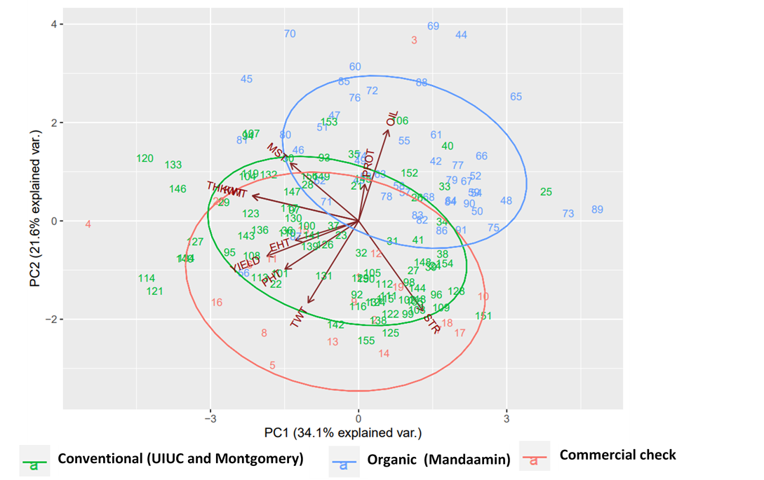

**Figure 1:** Biplot for all measured traits displaying patterns of hybrid performance based on breeding programs that developed the experimental hybrids**.** Abbreviations: PHT: Plant height, EHT: Ear height, TWT: Test weight, PROT: Protein content, STR: Starch content, THKWT: 300-kernel weight, MST: Moisture content

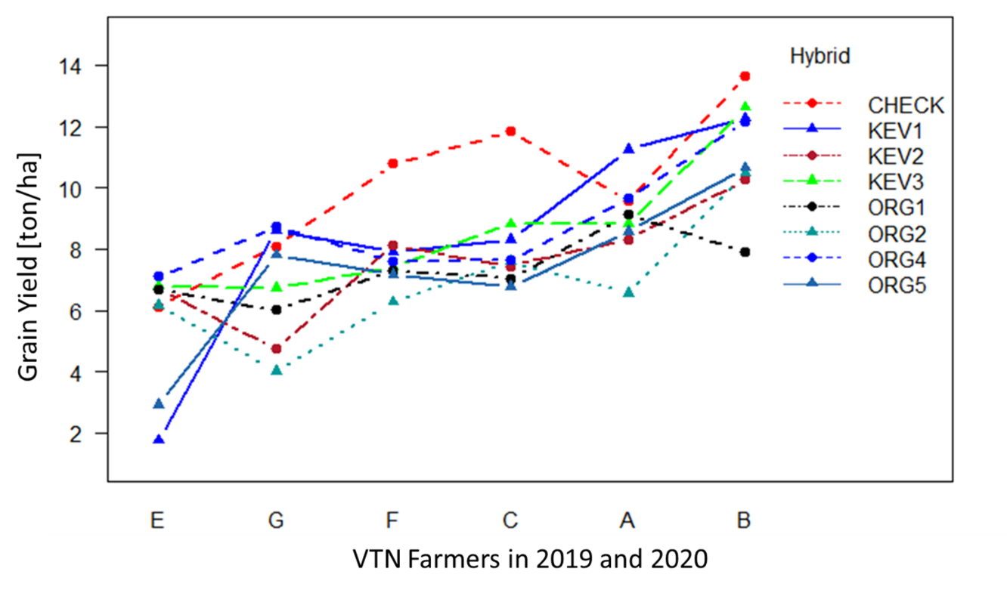

**Figure 2**: Two-way interaction between experimental hybrid and farmers in 2018.

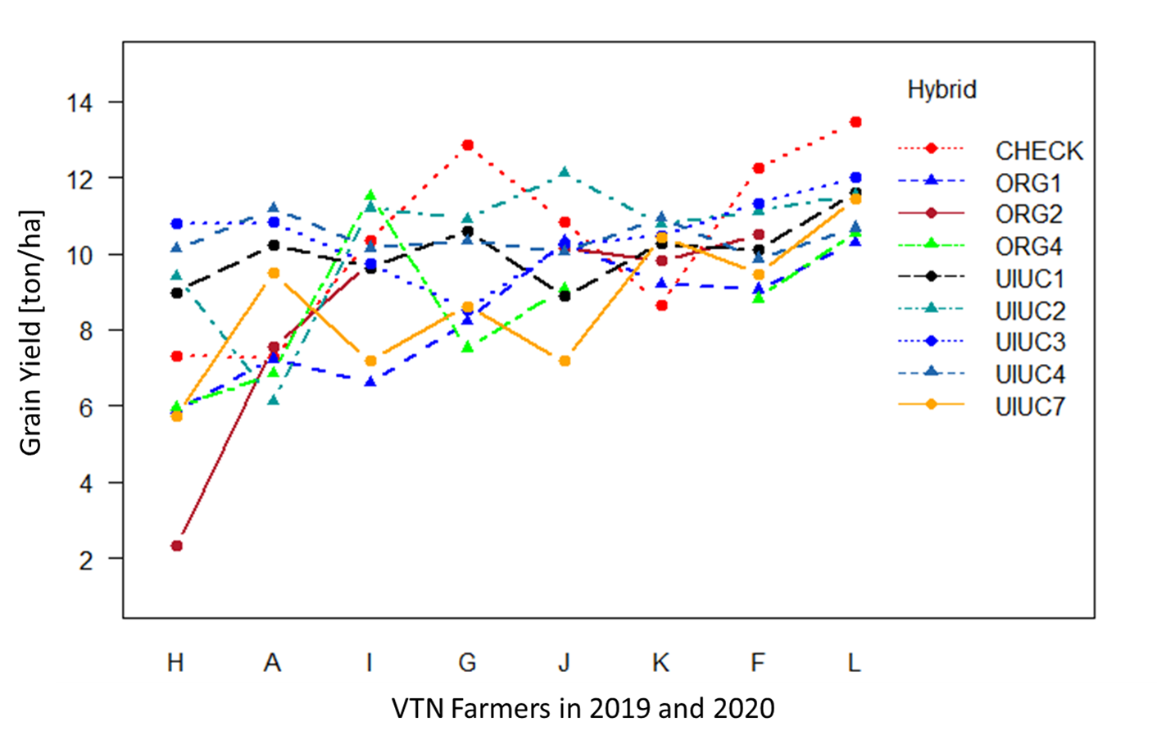

**Figure 3**: Two-way interaction between hybrids and farmers in 2019 and 2020.

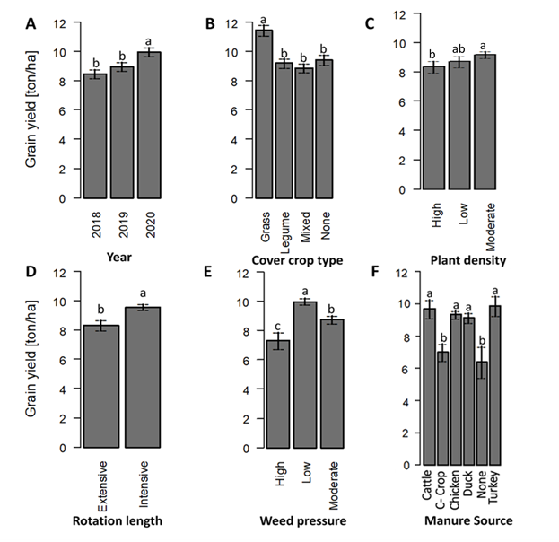

**Figure 4**: Effect of the different farmer management practices on the grain yield of the test hybrids. A shows grain yield across the three years of on-farm hybrid testing. Error bars represent standard error of the mean. Different letters denote significant differences among treatments at p ≤ 0.05

**SUPPLIMENTAL TABLES AND FIGURES**

**Table 12:** Mean grain yields (t ha-1), grain yield standard deviation (), number of environments where variety was tested (Env), number of environments where variety outperforms check (n), mean yield differences (), standard deviation of differences () and Reliabilities (, ) for the experimental hybrids grown under on-farm strip trials for individual years (2018, 2019 and 2020) with commercial variety 59R5 as the check.

|  |  |  |  |  |  |  |  |  |  |
| --- | --- | --- | --- | --- | --- | --- | --- | --- | --- |
| Year | Hybrid  name | Mean yield (t ha-1) |  | Env | n |  |  |  |  |
| 2018 | KEV1 | 8.14 | 3.40 | 7 | 2 | -1.63 | 2.17 | 0.226 | 0.286 |
| KEV2 | 7.34 | 1.80 | 7 | 1 | -2.43 | 1.63 | 0.068 | 0.143 |
| KEV3 | 8.31 | 2.10 | 7 | 1 | -1.47 | 1.37 | 0.142 | 0.143 |
| ORG1 | 7.34 | 1.08 | 6 | 1 | -2.66 | 2.45 | 0.138 | 0.167 |
| ORG2 | 6.85 | 2.12 | 6 | 1 | -3.16 | 1.67 | 0.030 | 0.167 |
| ORG4 | 8.82 | 1.88 | 6 | 2 | -1.19 | 2.13 | 0.288 | 0.333 |
| ORG5 | 7.31 | 2.55 | 6 | 0 | -2.69 | 1.75 | 0.062 | 0.000 |
|  | 59R5 | 9.77 | 2.52 | 7 | - | - | - | - | - |
| 2019 | ORG1 |  |  | 6 | 4 | -0.55 | 2.60 | 0.416 | 0.667 |
| 8.37 | 1.53 |
| ORG4 | 7.91 | 3.13 | 6 | 2 | -0.59 | 1.95 | 0.382 | 0.333 |
| UIUC1 | 7.18 | 1.34 | 6 | 3 | 0.05 | 1.97 | 0.511 | 0.500 |
| UIUC2 | 7.44 | 1.36 | 6 | 4 | 1.05 | 2.85 | 0.644 | 0.667 |
| UIUC3 | 8.00 | 1.28 | 6 | 3 | 0.91 | 2.27 | 0.656 | 0.500 |
| UIUC4 | 8.24 | 0.96 | 6 | 5 | 0.79 | 2.66 | 0.617 | 0.833 |
|  | UIUC7 | 8.34 | 3.00 | 6 | 1 | -1.29 | 2.85 | 0.325 | 0.167 |
|  | 59R5 | 8.93 | 2.83 | 6 | - | - | - | - | - |
| 2020 | ORG1 |  |  | 7 | 0 | -3.11 | 1.61 | 0.027 | 0.000 |
| 7.95 | 2.79 |
| ORG4 | 8.33 | 2.00 | 7 | 2 | -2.45 | 2.78 | 0.188 | 0.286 |
| UIUC1 | 8.37 | 0.61 | 7 | 2 | -0.46 | 3.12 | 0.441 | 0.286 |
| UIUC2 | 8.50 | 2.84 | 7 | 2 | -0.61 | 1.20 | 0.305 | 0.286 |
| UIUC3 | 8.45 | 1.60 | 7 | 2 | 0.05 | 3.62 | 0.505 | 0.286 |
| UIUC4 | 9.11 | 0.82 | 7 | 2 | -0.16 | 3.47 | 0.482 | 0.286 |
| UIUC7 | 8.71 | 1.47 | 7 | 1 | -2.10 | 3.04 | 0.245 | 0.143 |
|  | 59R5 | 11.06 | 3.03 | 7 | - | - | - | - | - |

|  |  |  |  |  |  |
| --- | --- | --- | --- | --- | --- |
| Hybrid | Pedigree | Maturity | Characteristics | Source | Year Tested |
| UIUC1 | PHHB9*PHM49 | 112 | Yellow dent, good root strength | UIUC | 2019 - 2020 |
| UIUC2 | PHHB9*PHR63 | 114 | Yellow dent, good root strength | UIUC | 2019 - 2020 |
| UIUC3 | PHHB9*PHW30 | 112 | Yellow dent, good yield | UIUC | 2019 - 2020 |
| UIUC4 | PHHB9*PHZ51 | 113 | Yellow dent, Higher yields under low N availability | UIUC | 2019 - 2020 |
| UIUC7 | PHW52*LH185 | 112 | Yellow dent | UIUC | 2019 - 2020 |
| ORG1 | 17.461 | 104-107 | High methionine, N-use efficient, and high nutritional value | Mandaamin Institute | 2018 - 2020 |
| ORG2 | 461.2B24 | 108-111 | High methionine, soft kernelled, N-use efficient, high yield. | Mandaamin Institute | 2018 |
| ORG4 | 17.2B24 | 108-114 | High methionine, N-use efficient, high yield | Mandaamin Institute | 2018-2020 |
| ORG5 | NG10.S7 | 108-114 | High methionine, soft kernelled, N-use efficient, high yield. | Mandaamin Institute | 2018 |
| KEV1 | F34.A22 | - | Developed and pre-screened under conventional conditions | Montgomery Consulting | 2018 |
| KEV2 | H69.A22 | - | Developed and pre-screened under conventional conditions | Montgomery Consulting | 2018 |
| KEV3 | P31.A22 | - | Developed and pre-screened under conventional conditions | Montgomery Consulting | 2018 |
| CHECK | 59R5 | 109 | yellow orange, hard kernel high yield, food grade | Great Harvest Organics | 2019 - 2020 |

**Table 13**: A list of the hybrids used in the controlled experiment with their respective characteristics, breeding program they were developed and the respective years they were used in the on-farm strip trials.

**Table 14:** A summary of the agronomic management practices across years and farmers in the testing network.

|  |  |  |  |  |  |
| --- | --- | --- | --- | --- | --- |
| Year | Farm Code | State | Location (City) | GPS Coordinates | Elevation (m.a.s.l.) |
| 2018 | C | Illinois | Pana | 39°28'41.1"N 89°00'18.7"W | 199 m |
| 2018 | B | Illinois | Sullivan | 39°37'23"N 88°40'37"W | 201 |
| 2018 | F | Illinois | Macomb | 40°40'02"N 90°45'10.7"W | 241 |
| 2018 | E | Illinois | Watseka | 40°49'27"N 87°45'32"W | 194 |
| 2018 | G | Illinois | Ashkum | 40°51'24.6"N 88°04'52.8"W | 199 |
| 2018 | D | Illinois | Paxton | 40°26'41" N 88°04'43" W | 236 |
| 2018 | A | Indiana | Tri-Lakes | 41°19'31.6"N 85°33'55.7"W | 288 |
| 2019 | F | Illinois | Macomb | 40°40'02"N 90°45'10.7"W | 241 |
| 2019 | H | Illinois | Reynolds | 41°19'57.4"N 90°39'40.3"W | 243 |
| 2019 | J | Illinois | Peoria | 40°37'10.8"N 89°42'28.1"W | 195 |
| 2019 | K | Indiana | Berne | 40°37'51.6"N 84°59'52.8"W | 254 |
| 2019 | A | Indiana | Sparta | 41°21'19.0"N 85°35'49.0"W | 280 |
| 2019 | I | Indiana | Richmond | 39°55'12.0"N 85°01'08.0"W | 317 |
| 2020 | F | Illinois | Macomb | 40°40'02"N 90°45'10.7"W | 241 |
| 2020 | J | Illinois | Peoria | 40°39'18.4"N 89°43'41.2"W | 198 |
| 2020 | H | Illinois | Reynolds | 41°19'47.4"N 90°39'47.6"W | 245 |
| 2020 | G | Illinois | Wellington | 40°31'50.2"N 87°42'06.0"W | 209 |
| 2020 | I | Indiana | New Lisbon | 39°52'23.6"N 85°13'43.9"W | 332 |
| 2020 | L | Indiana | Salem | 40°44'42.8"N 84°52'12.9"W | 250 |
| 2020 | A | Indiana | Roanoke | 40°55'08.8"N 85°22'18.3"W | 232 |

**Table 15:** A summary of the agronomic management practices across years and farmers in the testing network.

|  |  |  |  |  |  |  |  |  |  |
| --- | --- | --- | --- | --- | --- | --- | --- | --- | --- |
| Year | Farm | PPD | State | C-Crop | WRT | PDTY | MSRC | YOM | RTNL |
| 2018 | A | 5/27/2018 | Indiana | None | Moderate | 69000 | Duck | 6 | 3 |
| 2018 | B | 5/23/2018 | Illinois | Mixed | Low | 79000 | Beef | 1 | 2 |
| 2018 | C | 5/28/2018 | Illinois | Mixed | High | 79000 | Beef | 28 | 4 |
| 2018 | D | 5/19/2018 | Illinois | Mixed | Moderate | 79000 | CC | 0 | 4 |
| 2018 | E | 5/28/2018 | Illinois | NA | Moderate | NA | Potash | NA | NA |
| 2018 | F | 6/7/2018 | Illinois | Mixed | Low | 79000 | Chicken | 20 | 4 |
| 2018 | G | 5/22/2018 | Illinois | Legume | Moderate | 79000 | Chicken | 10 | 3 |
| 2019 | A | 6/8/2019 | Indiana | Mixed | Moderate | 69000 | Duck | 6 | 3 |
| 2019 | H | 5/15/2019 | Illinois | Mixed | High | 86500 | None | 13 | 5 |
| 2019 | F | 6/11/2019 | Illinois | Mixed | Low | 79000 | Chicken | 20 | 4 |
| 2019 | I | 6/3/2019 | Indiana | Legume | Low | 79000 | Chicken | 3 | 2 |
| 2019 | J | 6/11/2019 | Illinois | Legume | Low | 86500 | Turkey | 4 | 3 |
| 2019 | K | 6/12/2019 | Indiana | None | Moderate | 79000 | Chicken | 3 | 3 |
| 2020 | A | 5/12/2020 | Indiana | Mixed | Moderate | 74000 | Chicken | 3 | 3 |
| 2020 | L | 6/9/2020 | Indiana | Grass | Low | 79000 | Chicken | NA | 2 |
| 2020 | H | 5/1/2020 | Illinois | None | Moderate | 81500 | Potash | 14 | 4 |
| 2020 | F | 6/4/2020 | Illinois | Mixed | Low | 79000 | Chicken | 20 | 2 |
| 2020 | I | 5/27/2020 | Indiana | Legume | Low | 84000 | Chicken | 3 | 3 |
| 2020 | J | 5/31/2020 | Illinois | Legume | Low | 86500 | Turkey | 5 | 2 |
| 2020 | G | 6/8/2020 | Illinois | Legume | Moderate | 86500 | Chicken | 6 | 3 |

Abbreviations: PPD: Planting Date, C-Crop: Cover crop type, WRT: Weed pressure rate. PDTY: Planting density, MSRC: Manure source, YOM: Years of organic management, RTNL: Rotation length.